Legend
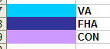

The following excel spreadsheet foreclosure tracking board 2014.xls, illustrates actions that need to be taken after we foreclose.

VA

*1st legal: date that attorneys posted at the courthouse prior to foreclosure, this info resides in MS
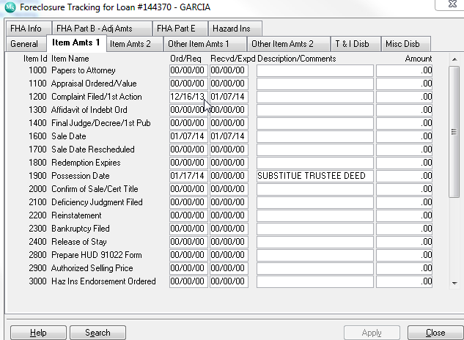
Metric: pick duedate and 1st legal needs to come in 5 months after due date if this is not the case we need to change color or provide an alert that first legal is beyond due date

*UPB:Unpaid Principal Balance, if foreclosre not final we pick the info from the ‘current principal balance” if paid off or foreclosed then we pick amount from “principal paid”

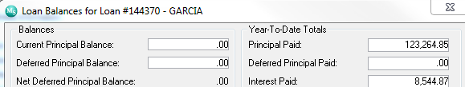

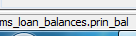
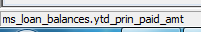

If loan is paid off principal = 0 then go to investor/service fee
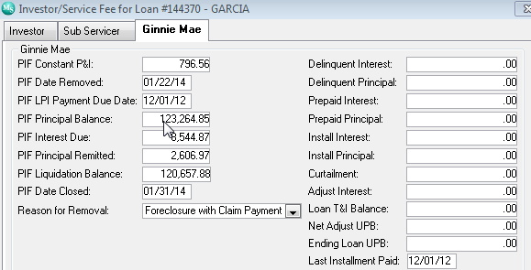

*F/C DATE
Date Foreclosed
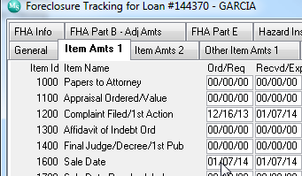
Line 1600 sale date ord/req
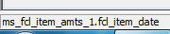

*RESULTS OF SALE : NOTIFICATION THRU VALERIE OF FORECLOSURE SALE RESULTS.
METRIC NEEDS TO BE DONE WITHIN 24 HOURS OF FORECLOSURE DATE
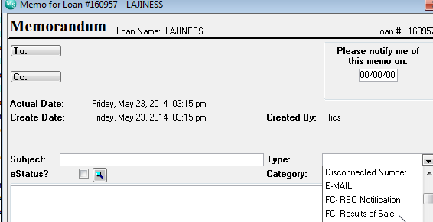

Info comes from memo type fc- reo notification, this is a date field , please populate create date
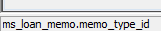

* Transfer of Custody (15 Days from Sale): when RMMC conveys property to VA
Metric it needs to be done within 15 days of sale, serv will need to be notified via email and color 7 days prior to those 15 days
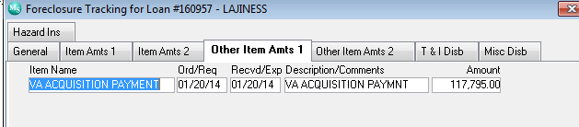
This is a date field ord/req please ensure “va acquisition payment’ is the descption

*VA Acquisition Payment Date:
Now this is the rec/exp another date field

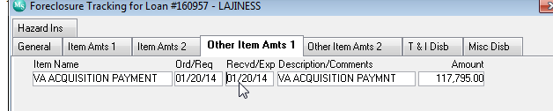

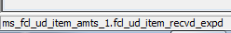

*VA Acquisition Payment Amount:
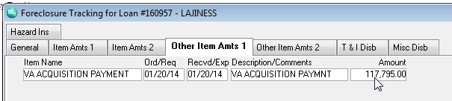
This is a numeric field amount

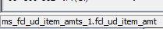

*VA Basic Claim Date:

Date when we submit a claim for loss to VA

Metric: 45 days of foreclure date

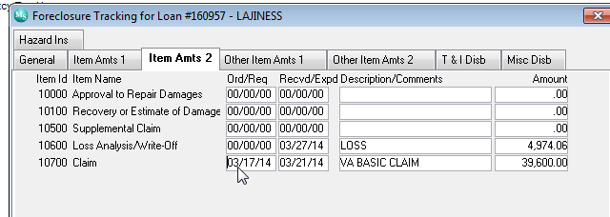
field 10700 claim , ord/req

*VA Summary of Claim Date: when claim is received date

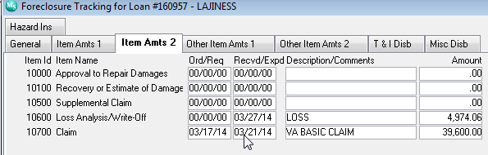
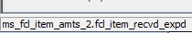 this is a date field again 10700 , recv/expd

*VA Claim Amount

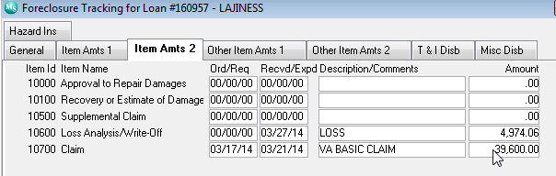
Again line 10700 amount , numeric



